**LAB # 10**

**Active Filters**



**SUBMITTED BY:**

Awais Saddiqui

**REG NO:**

21PWCSE1993

**SECTION:**

“A”

**SUMITTED TO:**

Engineer Faiz Ullah Sir

**UNIVERSITY OF ENGINEERING AND TECHNOLOGY PESHAWAR**

**COMPUTER SYSTEM ENGINEERING**

**ASSESSMENT RUBRICS**

|  |  |  |  |  |  |
| --- | --- | --- | --- | --- | --- |
|  | LAB REPORT ASSESSMENT | | | | |
|  | Criteria | Excellent | Average | Nil | Marks Obtained |
| 1. | Objectives of Lab | All objectives of lab are properly covered [Marks 1] | Objectives of lab are partially covered [Marks 0.5] | Objectives of lab are  not shown  [Marks 0] |  |
| 2. | Procedure | All experimental steps are shown. [Marks 2] | Some of the experimental steps are shown.  [Marks 1] | Experimental steps  not shown [Marks 0] |  |
| 3. | Demonstration of Concepts | The student demonstrated a clear understanding of the assignment concepts  [Marks 2] | The student demonstrated a clear understanding of some of the assignment concepts [Marks 1] | The student failed to demonstrate a clear understanding of the assignment concepts  [Marks 0] |  |
| 4. | Experimental  Results | All experimental results are completely shown in  form of table [Marks 3] | Experimental results are partially shown and some of the observations are missing [Marks 1.5] | No experimental results are shown  [Marks 0] |  |
| 5. | conclusion | Conclusion of the lab is properly written  [Marks 2] | Conclusion of the lab is partially written  [Marks 1] | Conclusion of lab is not written [Marks 0] |  |
|  | Total Marks Obtained: __________    Instructor Signature: ______________________ | | | | |

## Low Pass Filter

## Objectives:

To study the Active Low pass filter and to evaluate:

• High cutoff frequency of Low pass filter.

• Pass band gain of Low pass filter.

• Plot the frequency response of Low pass filter.

## Equipment:

1. DC power supplies +15V, −15V from external source

2. Function generator

3. Oscilloscope

4. Digital Multimeter

## Components:

1. Resistance 10kΩ

2. Resistance 22kΩ

3. Capacitor 0.01μF

4. LM 741

## Equation of low pass filter

## Vin =Input signal Voltage

## Vout = Output signal Voltage

## | Vout/Vin |= Gain of filter as a function of frequency

## AF =1+RF/R1 = pass band gain of filter

## f = frequency of input signal

## fH =1/2πRC =high cut off frequency, 3-dB frequency, corner frequency

## Operation of low pass filter using equation 2

## The ideal low pass filter has a constant gain AF from 0 to high cut off frequency (fH) at fH the

## gain is 0.707 * AF, and after fH it decreases at a constant rate with an increase in frequency i.e.,

## when input frequency is increased tenfold (one decade), the voltage gain is divided by 10. Gain

## (dB) = 20 log | Vout / Vin | i.e., Gain Roll off rate is −20dB / decade.

## Procedure

1. Connect the circuit as shown in Figure 2.

2. Switch ON the power supply

3. Connect a sinusoidal signal of amplitude 1V (p-p) of frequency 1KHz to Vin of Low

pass filter from function generator

4. Connect Ch-1 of oscilloscope to the signal source

5. Observe output on Ch-2 of oscilloscope

6. Increase the frequency of input signal step by step and observe the effect on output

Vout on oscilloscope

7. Tabulate values of Vout, gain, gain (dB) at different values of input frequency shown

in observation Table 2.

8. Plot the frequency response of low pass filter using the data obtained at different

input frequencies.

## Theoretical Calculations:

Calculate all the following values

1. Pass band gain of Low pass filter AF = 1 + RF / R1

2. Pass band gain (dB) = 20 log |Vout / Vin|

3. 3 dB frequency fH = 1/2πRC

4. Gain at 3 dB frequency fH = 0.707 * AF

5. Roll off rate = −20db/decade

**Proteus Circuit:**

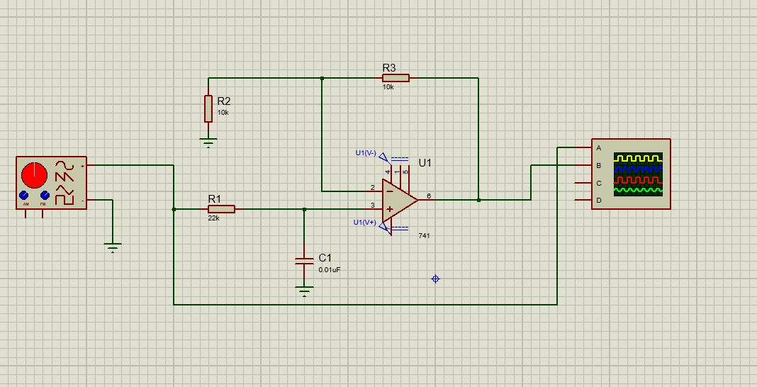

## Results:

|  |  |  |
| --- | --- | --- |
|  | **Theoretical** | **Practical** |
| **Pass band gain (Ar)** | **2** | **2** |
| **Pass band gain (Ar) in db** | **6** | **6** |
| **3db frequency fH** | **723** | **722** |
| **Gain at 3db frequency (fH) in db** | **1.414** | **1.414** |

## Table 2:

|  |  |  |  |  |
| --- | --- | --- | --- | --- |
| **S.No** | **Input Frequency (Hz)** | **Vout** | **|Vout/vin|=Gain** | **Gain(db)=20log|Vout/Vin|** |
| **1** | **300** | **9.18** | **1.8** | **5.182** |
| **2** | **500** | **8.2** | **1.62** | **4.1** |
| **3** | **700** | **7.33** | **1.44** | **3.3** |
| **4** | **1k** | **5.79** | **1.15** | **1.5** |
| **5** | **5k** | **1.43** | **0.28** | **-11.4** |
| **6** | **10k** | **0.70** | **0.14** | **-16.8** |
| **7** | **15k** | **0.4** | **0.096** | **-20.33** |

## Conclusion:

A low-pass filter is a filter that passes signals with a frequency lower than a selected cutoff frequency and attenuates signals with frequencies higher than the cutoff frequency. The exact frequency response of the filter depends on the filter design.